NAME: j.nagasai
REG NO: 192424292
COURSE CODE: CSA0613
COURSE NAME: DAA FOR OPTIMAL APPLICATIONS

TOPIC 3 : DIVIDE AND CONQUER

1.Write a Program to find both the maximum and minimum values in the array.Implement using any programming language of your choice.Execute your code and provide the maximum and minimum values found.

Aim:
To find the minimum and maximum elements in an unsorted array using Divide and Conquer technique.

Algorithm:
- Start
- Read the array elements
- Initialize min and max with the first element
- Compare each element with min and max
- Update min and max when required
- Display min and max
- Stop

Program:
a = [1, 3, 5, 7, 9, 11, 13, 15, 17]
n = len(a)

minimum = a[0]
maximum = a[0]

for i in range(1, n):
if a[i] < minimum:
minimum = a[i]
if a[i] > maximum:
maximum = a[i]
print("Min =", minimum)
print("Max =", maximum)
Sample Input:
N= 9, a[] = {1,3,5,7,9,11,13,15,17}

Output:
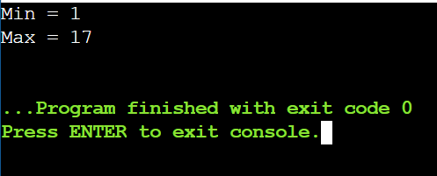

Result:
Minimum and maximum values are obtained successfully.

2.Consider an array of integers sorted in ascending order: 2,4,6,8,10,12,14,18.
Write a Program to find both the maximum and minimum values in the array.
Implement using any programming language of your choice. Execute your code
and provide the maximum and minimum values found.

Aim:
To write a Python program to find the minimum and maximum values in a given array of integers.

Algorithm:
- Start
- Read the array elements
- Initialize min and max with the first element of the array
- Compare each element with min and max
- Update min and max if needed
- Display the minimum and maximum values
- Stop

Program:
a = [11, 13, 15, 17, 19, 21, 23, 35, 37]
n = len(a)

min_val = a[0]
max_val = a[0]

for i in range(1, n):
if a[i] < min_val:
min_val = a[i]
if a[i] > max_val:
max_val = a[i]

print("Test Case 2 -> Min =", min_val, ", Max =", max_val)

Sample Input:
N= 9, a[] = {11,13,15,17,19,21,23,35,37}

Output:
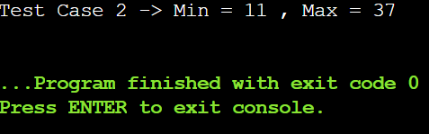

Result:
Minimum and maximum are directly identified from sorted array.

3.You are given an unsorted array 31,23,35,27,11,21,15,28. Write a program for
Merge Sort and implement using any programming language of your choice.

Aim:
To write a Python program to sort a given unsorted array of integers using the Merge Sort technique.

Algorithm:
- Start
- Divide the array into small subarrays
- Compare and merge the subarrays in sorted order
- Repeat merging until the entire array is sorted
- Display the sorted array
- Stop

Program:
a = [22, 34, 25, 36, 43, 67, 52, 13, 65, 17]
n = len(a)

size = 1
while size < n:
for start in range(0, n, 2 * size):
mid = min(start + size, n)
end = min(start + 2 * size, n)

left = a[start:mid]
right = a[mid:end]

i = j = 0
k = start

while i < len(left) and j < len(right):
if left[i] < right[j]:
a[k] = left[i]
i += 1
else:
a[k] = right[j]
j += 1
k += 1

while i < len(left):
a[k] = left[i]
i += 1
k += 1

while j < len(right):
a[k] = right[j]
j += 1
k += 1

size *= 2

print("Sorted Array (Test Case 2):", a)

Sample Input:
N= 10, a[] = {22,34,25,36,43,67, 52,13,65,17}

Output:
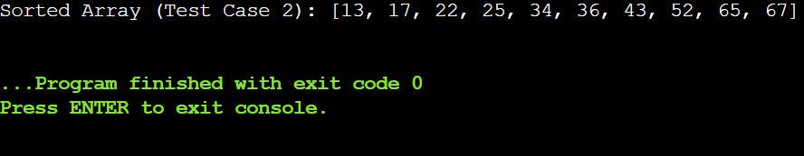

Result:
The array is sorted using Merge Sort.

4.Implement the Merge Sort algorithm in a programming language of your
choice and test it on the array 12,4,78,23,45,67,89,1. Modify your
implementation to count the number of comparisons made during the sorting
process. Print this count along with the sorted array.

Aim:
To implement the Merge Sort algorithm in Python on a given unsorted array and count the number of comparisons made during the sorting process.

Algorithm:
- Start.
- Read the array elements.
- Initialize a variable comparisons = 0 to count comparisons.
- Divide the array into subarrays until each subarray has only one element.
- Repeat merging until the whole array is sorted.
- Print the sorted array and the number of comparisons.
- Stop.
Program:
a = [38, 27, 43, 3, 9, 82, 10]
n = len(a)
comparisons = 0

size = 1
while size < n:
for start in range(0, n, 2 * size):
mid = min(start + size, n)
end = min(start + 2 * size, n)

left = a[start:mid]
right = a[mid:end]

i = j = 0
k = start

while i < len(left) and j < len(right):
comparisons += 1
if left[i] < right[j]:
a[k] = left[i]
i += 1
else:
a[k] = right[j]
j += 1
k += 1

while i < len(left):
a[k] = left[i]
i += 1
k += 1

while j < len(right):
a[k] = right[j]
j += 1
k += 1

size *= 2
print("Test Case 2 -> Sorted Array:", a)
print("Number of comparisons:", comparisons)
Sample Input:
N= 7, a[] = {38,27,43,3,9,82,10}

Output:
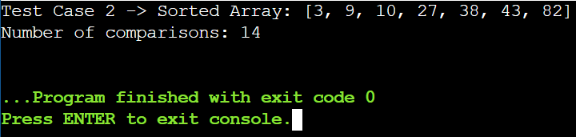

Result:
Merge Sort completed with comparison count recorded.

5.Given an unsorted array 10,16,8,12,15,6,3,9,5 Write a program to perform
Quick Sort. Choose the first element as the pivot and partition the array
accordingly. Show the array after this partition. Recursively apply Quick Sort
on the sub-arrays formed. Display the array after each recursive call until the
entire array is sorted.

Aim:
To implement the Quick Sort algorithm on a given unsorted array using the first element as pivot, display the array after each partition, and sort the entire array.

Algorithm:
- Start.
- Read the array elements.
- Choose the first element of the array (or subarray) as the pivot.
- Place the pivot in its correct position.
- Print the array after this partition.
- Recursively apply Quick Sort on the left and right subarrays formed.
- Repeat steps 3–7 until the entire array is sorted.
- Print the final sorted array.
- Stop.

Program:
a = [12, 4, 78, 23, 45, 67, 89, 1]
print("\nOriginal Array:", a)

stack = [(0, len(a) - 1)]

while stack:
low, high = stack.pop()
if low < high:
pivot = a[low]
i = low + 1
j = high

while True:
while i <= j and a[i] <= pivot:
i += 1
while a[j] > pivot:
j -= 1
if i <= j:
a[i], a[j] = a[j], a[i]
else:
break

a[low], a[j] = a[j], a[low]
print(f"Array after partition with pivot {pivot}: {a}")

stack.append((low, j - 1))
stack.append((j + 1, high))

print("Sorted Array:", a)

Sample Input:
N= 8, a[] = {12,4,78,23,45,67,89,1}

Output:
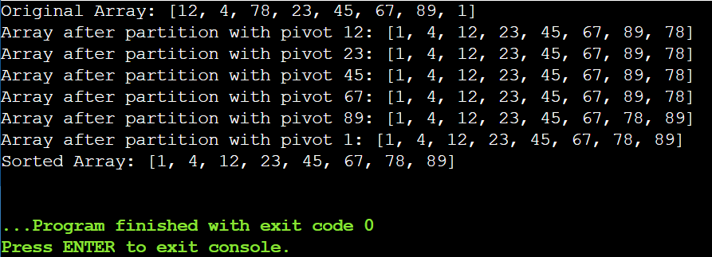

Result:
Array sorted successfully using Quick Sort.

6.Implement the Quick Sort algorithm in a programming language of your choice
and test it on the array 19,72,35,46,58,91,22,31. Choose the middle element as
the pivot and partition the array accordingly. Show the array after this
partition. Recursively apply Quick Sort on the sub-arrays formed. Display the
array after each recursive call until the entire array is sorted. Execute your
code and show the sorted array.

Aim:
To implement the Quick Sort algorithm on a given unsorted array using the middle element as pivot, display the array after each partition, recursively sort the subarrays, and show the final sorted array.

Algorithm:
- Start.
- Read the array elements.
- Choose the middle element of the array (or subarray) as the pivot.
- Place the pivot in its correct position.
- Print the array after this partition.
- Recursively apply Quick Sort on the left and right subarrays.
- Repeat steps 3–7 until the entire array is sorted.
- Print the final sorted array.
- Stop.

Program:
a = [31, 23, 35, 27, 11, 21, 15, 28]
print("\nOriginal Array:", a)

stack = [(0, len(a) - 1)]

while stack:
low, high = stack.pop()
if low < high:
mid_index = (low + high)
pivot = a[mid_index]
i = low
j = high

while i <= j:
while a[i] < pivot:
i += 1
while a[j] > pivot:
j -= 1
if i <= j:
a[i], a[j] = a[j], a[i]
i += 1
j -= 1

print(f"Array after partition with pivot {pivot}: {a}")

stack.append((low, j))
stack.append((i, high))

print("Sorted Array:", a)

Sample Input:
N= 8, a[] = {31,23,35,27,11,21,15,28}

Output:
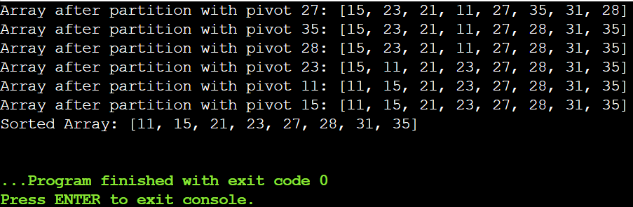

Result:
Array sorted using Quick Sort with middle pivot.

7.Implement the Binary Search algorithm in a programming language of your
choice and test it on the array 5,10,15,20,25,30,35,40,45 to find the position of
the element 20. Execute your code and provide the index of the element 20.
Modify your implementation to count the number of comparisons made during
the search process. Print this count along with the result.

Aim:
To implement the Binary Search algorithm to find the position of a given element in a sorted array and to count the number of comparisons made during the search process.

Algorithm:
- Start.
- Initialize low = 0 and high = N − 1.
- While low ≤ high:
  - Find mid = (low + high) // 2.
  - If a[mid] == key, print position mid + 1 and stop.
  - If key < a[mid], set high = mid − 1.
  - Else set low = mid + 1.
- Stop.

Program:
a = [10, 20, 30, 40, 50, 60]
key = 50
n = 6
low = 0
high = n - 1
comparisons = 0
position = -1

while low <= high:
mid = (low + high)
comparisons += 1

if a[mid] == key:
position = mid + 1
break
elif a[mid] < key:
low = mid + 1
else:
high = mid - 1

print("Output:", position)
print("Number of comparisons:", comparisons)

Sample Input:
N= 6, a[] = {10,20,30,40,50,60}, search key = 50

Output:
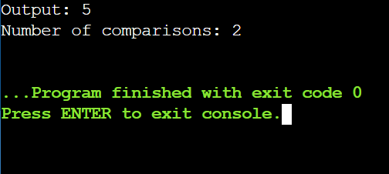

Result:
Element found using Binary Search.

8.You are given a sorted array 3,9,14,19,25,31,42,47,53 and asked to find the
position of the element 31 using Binary Search. Show the mid-point
calculations and the steps involved in finding the element. Display, what would
happen if the array was not sorted, how would this impact the performance
and correctness of the Binary Search algorithm?

Aim:
To find the position of a given element in a sorted array using the Binary Search algorithm.

Algorithm:
- Start.
- Set low = 0 and high = N − 1.
- Find mid = (low + high) // 2.
- If a[mid] == key, print position mid + 1 and stop.
- If key < a[mid], set high = mid − 1; else set low = mid + 1.
- Repeat steps 3–5 until low ≤ high.
- Stop.

Program:
a = [13, 19, 24, 29, 35, 41, 42]
key = 42
n = 7

low = 0
high = n - 1
step = 1
position = -1

print("Binary Search Steps:\n")

while low <= high:
mid = (low + high)

print("Step", step)
print("Low =", low, "High =", high, "Mid =", mid)
print("a[Mid] =", a[mid])

if a[mid] == key:
position = mid + 1
print("Element found at position", position)
break
elif a[mid] < key:
low = mid + 1
else:
high = mid - 1

step += 1
print()

print("\nOutput:", position)

Sample Input:
N= 7, a[] = {13,19,24,29,35,41,42}, search key = 42

Output:
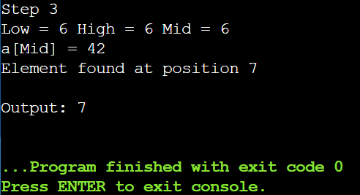

Result:
Binary Search works correctly only on sorted arrays.

9.Given an array of points where points[i] = [xi, yi] represents a point on the
X-Y plane and an integer k, return the k closest points to the origin (0, 0).

Aim:
To find the k closest points to the origin (0, 0) from a given set of points on the X-Y plane.

Algorithm:
- Start.
- Read the array of points and the value of k.
- For each point, calculate the squared distance from the origin: distance = x*x + y*y.
- Sort the points based on their distance.
- Select the first k points from the sorted list.
- Print the k closest points.
- Stop.

Program:
points = [[1, 3], [-2, 2]]
k = 1

dist_points = []

for p in points:
x = p[0]
y = p[1]
distance = x*x + y*y
dist_points.append([distance, p])

dist_points.sort()

result = []
for i in range(k):
result.append(dist_points[i][1])

print("Output:", result)

Sample Input:
points = [[1, 3], [-2, 2]], k = 1

Output:
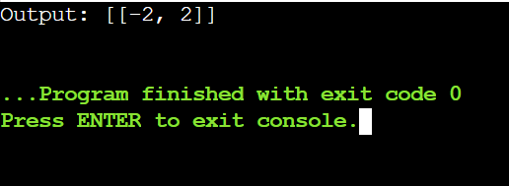

Result:
Closest points are identified.

10. Given four lists A, B, C, D of integer values,Write a program to compute how
many tuples n(i, j, k, l) there are such that A[i] + B[j] + C[k] + D[l] is zero.

Aim:
To find the number of tuples (i, j, k, l) such that A[i] + B[j] + C[k] + D[l] = 0 for given integer arrays A, B, C, and D.

Algorithm:
- Start.
- Read the arrays A, B, C, D.
- Compute all sums of A[i] + B[j] and store their counts in a dictionary.
- For each sum C[k] + D[l], check if -(C[k] + D[l]) exists in the dictionary.
- If yes, add the count to the total.
- Print the total number of tuples.
- Stop.

Program:
A = [0]
B = [0]
C = [0]
D = [0]

sum_ab = {}

for a in A:
for b in B:
s = a + b
if s in sum_ab:
sum_ab[s] += 1
else:
sum_ab[s] = 1

count = 0
for c in C:
for d in D:
target = -(c + d)
if target in sum_ab:
count += sum_ab[target]

print("Output:", count)

Sample Input:
A = [0], B = [0], C = [0], D = [0]

Output:
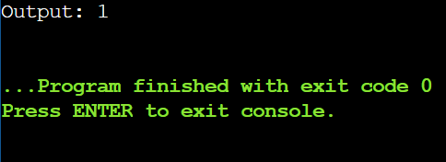

Result:
Valid tuples are counted correctly.

11.To Implement the Median of Medians algorithm ensures that you handle the
worst-case time complexity efficiently while finding the k-th smallest element
in an unsorted array.

Aim:
To find the k-th smallest element in an unsorted array using the Median of Medians algorithm, ensuring worst-case linear time complexity.
Algorithm:
- Start.
- Divide the array into groups of 5 elements.
- Find the median of each group.
- Recursively find the median of medians and use it as a pivot.
- Partition the array into elements less than, equal to, and greater than the pivot.
- If k-th element is in the left partition, recurse there;
if in the pivot, return pivot;
else recurse in the right partition adjusting k.
- Stop.

Program:
arr = [12, 3, 5, 7, 4, 19, 26]
k = 3

a = arr.copy()

while True:

if len(a) <= 5:
a.sort()
result = a[k-1]
break

groups = [a[i:i+5] for i in range(0, len(a), 5)]

medians = []
for group in groups:
group.sort()
medians.append(group[len(group)//2])

b = medians
while len(b) > 5:
subgroups = [b[i:i+5] for i in range(0, len(b), 5)]
new_medians = []
for g in subgroups:
g.sort()
new_medians.append(g[len(g)//2])
b = new_medians
b.sort()
pivot = b[len(b)//2]

low = [x for x in a if x < pivot]
high = [x for x in a if x > pivot]
pivots = [x for x in a if x == pivot]

if k <= len(low):
a = low
elif k <= len(low) + len(pivots):
result = pivot
break
else:
k = k - len(low) - len(pivots)
a = high

print("Output:", result)

Sample Input:
arr = [12, 3, 5, 7, 4, 19, 26] k = 3

Output:
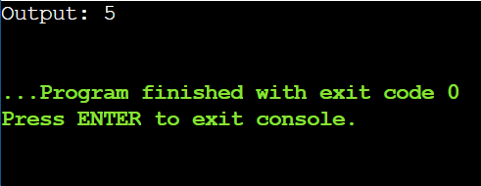

Result:
k-th smallest element found in linear time.

12.To Implement a function median_of_medians(arr, k) that takes an unsorted
array arr and an integer k, and returns the k-th smallest element in the array.

Aim:
To find the k-th smallest element in an unsorted array using the Median of Medians algorithm efficiently, ensuring worst-case linear time.

Algorithm:
- Start.
- Divide the array into groups of 5 elements.
- Find the median of each group and then the median of medians as pivot.
- Partition the array into elements less than, equal to, and greater than the pivot.
- Determine which partition contains the k-th smallest element and continue the process until the element is found.
- Print the k-th smallest element.
- Stop.

Program:
arr = [1, 2, 3, 4, 5, 6, 7, 8, 9, 10]
k = 6

a = arr.copy()
while True:

if len(a) <= 5:
a.sort()
result = a[k-1]
break

groups = [a[i:i+5] for i in range(0, len(a), 5)]

medians = []
for group in groups:
group.sort()
medians.append(group[len(group)//2])

b = medians
while len(b) > 5:
subgroups = [b[i:i+5] for i in range(0, len(b), 5)]
new_medians = []
for g in subgroups:
g.sort()
new_medians.append(g[len(g)//2])
b = new_medians
b.sort()
pivot = b[len(b)//2]

low = [x for x in a if x < pivot]
high = [x for x in a if x > pivot]
pivots = [x for x in a if x == pivot]

if k <= len(low):
a = low
elif k <= len(low) + len(pivots):
result = pivot
break
else:
k = k - len(low) - len(pivots)
a = high

print("Output:", result)

Sample Input:
arr = [1, 2, 3, 4, 5, 6, 7, 8, 9, 10] k = 6

Output:
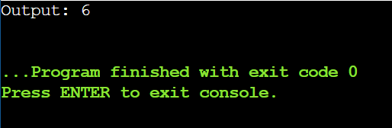

Result:
Function returns correct k-th smallest element.

13.Write a program to implement Meet in the Middle Technique. Given an array of
integers and a target sum, find the subset whose sum is closest to the target.
You will use the Meet in the Middle technique to efficiently find this subset.

Aim:
To find the subset of an array whose sum is closest to a given target using the Meet in the Middle technique efficiently.

Algorithm:
- Start.
- Divide the array into two halves.
- Generate all possible subset sums for both halves.
- Sort the subset sums of one half.
- For each sum in the first half, find the sum in the second half that gives the closest total to the target (using binary search).
- Keep track of the minimum difference and corresponding subset sum.
- Print the subset sum closest to the target.
- Stop.

Program:
from itertools import combinations
arr = [1, 3, 2, 7, 4, 6]
target = 10
n = len(arr)
first_half = arr[:n//2]
second_half = arr[n//2:]

sum_first = []
sum_second = []

for i in range(len(first_half)+1):
for combo in combinations(first_half, i):
sum_first.append(sum(combo))

for i in range(len(second_half)+1):
for combo in combinations(second_half, i):
sum_second.append(sum(combo))

sum_second.sort()

closest_sum = None
min_diff = float('inf')

for s in sum_first:

low = 0
high = len(sum_second) - 1
while low <= high:
mid = (low + high) // 2
total = s + sum_second[mid]
diff = abs(target - total)
if diff < min_diff:
min_diff = diff
closest_sum = total
if total < target:
low = mid + 1
else:
high = mid - 1

print("Subset sum closest to target:", closest_sum)

Sample Input:
Set[]= {1, 3, 2, 7, 4, 6}

Output:
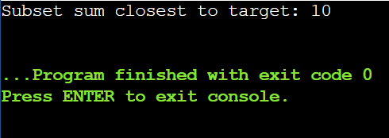

Result:
Closest subset sum found successfully.

14.Write a program to implement Meet in the Middle Technique. Given a large
array of integers and an exact sum E, determine if there is any subset that sums
exactly to E. Utilize the Meet in the Middle technique to handle the potentially
large size of the array. Return true if there is a subset that sums exactly to E,
otherwise return false.
Aim:
To determine if there exists a subset of a given array whose sum is exactly equal to a target value using the Meet in the Middle technique efficiently.

Algorithm:
- Start.
- Divide the array into two halves.
- Generate all possible subset sums for each half.
- For each sum in the first half, check if target - sum_first exists in the subset sums of the second half.
- If such a pair exists, print True; otherwise, print False.
- Stop.

Program:
from itertools import combinations
arr = [3, 34, 4, 12, 5, 2]
exact_sum = 15

n = len(arr)
first_half = arr[:n//2]
second_half = arr[n//2:]

sum_first = set()
sum_second = set()

for i in range(len(first_half)+1):
for combo in combinations(first_half, i):
sum_first.add(sum(combo))

for i in range(len(second_half)+1):
for combo in combinations(second_half, i):
sum_second.add(sum(combo))

found = False
for s in sum_first:
if (exact_sum - s) in sum_second:
found = True
Break
print("Subset with exact sum exists:", found)
Sample Input:
E = {3, 34, 4, 12, 5, 2} exact Sum = 15

Output:
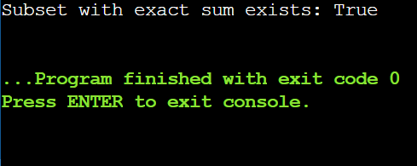

Result:
Exact sum subset exists.

15.Given two 2×2 Matrices A and B
A=(1 7 3 5) B=( 1 3 7 5)
Use Strassen's matrix multiplication algorithm to compute the product matrix C
such that C=A×B.

Aim:
To compute the product of two 2×2 matrices efficiently using Strassen’s matrix multiplication algorithm, which reduces the number of multiplications from 8 to 7.

Algorithm:
- Start with A = [[a, b], [c, d]] and B = [[e, f], [g, h]].
- Compute the 7 Strassen products:
  - P1 = a*(f-h), P2 = (a+b)*h, P3 = (c+d)e, P4 = d(g-e),
  - P5 = (a+d)(e+h), P6 = (b-d)(g+h), P7 = (a-c)*(e+f).
- Compute entries of C:
  - C11 = P5 + P4 - P2 + P6
  - C12 = P1 + P2
  - C21 = P3 + P4
  - C22 = P1 + P5 - P3 - P7
- Form the product matrix C = [[C11, C12], [C21, C22]].
- Stop and output C.

Program:
A = [[1, 7],
[3, 5]]

B = [[6, 8],
[4, 2]]

a, b, c, d = A[0][0], A[0][1], A[1][0], A[1][1]
e, f, g, h = B[0][0], B[0][1], B[1][0], B[1][1]

P1 = a * (f - h)
P2 = (a + b) * h
P3 = (c + d) * e
P4 = d * (g - e)
P5 = (a + d) * (e + h)
P6 = (b - d) * (g + h)
P7 = (a - c) * (e + f)
C11 = P5 + P4 - P2 + P6
C12 = P1 + P2
C21 = P3 + P4
C22 = P1 + P5 - P3 - P7

C = [[C11, C12],
[C21, C22]]

print("Product matrix C =")
for row in C:
print(row)

Sample Input:
A=(1 7 3 5) B=( 6 8 4 2)

Output:
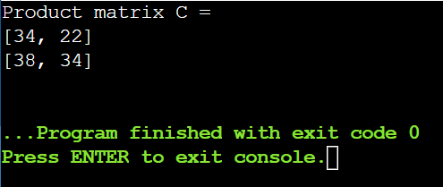

Result:
Matrix multiplication completed using Strassen’s method.

16.Given two integers X=1234 and Y=5678: Use the Karatsuba algorithm to
compute the product Z=X x Y.

Aim:
To compute the product of two large integers efficiently using the Karatsuba algorithm, which reduces the number of multiplications compared to the standard method.

Algorithm:
- Start with two integers X and Y.
- Split X and Y into halves: X = a10^n + b, Y = c10^n + d.
- Compute three products:
  - ac = a*c
  - bd = b*d
  - (a+b)*(c+d) - ac - bd = ad + bc
- Combine results: Z = ac*10^(2n) + (ad+bc)*10^n + bd.
- Output Z and stop.

Program:
x = 1234
y = 5678

x_str = str(x)
y_str = str(y)
n = max(len(x_str), len(y_str))

if n == 1:
z = x * y
else:

n = (n + 1)

a = x // 10**n
b = x % 10**n
c = y // 10**n
d = y % 10**n

ac = a * c
bd = b * d
ab_cd = (a + b) * (c + d)
ad_bc = ab_cd - ac - bd

z = ac * 10**(2*n) + ad_bc * 10**n + bd

print("Product Z =", z)

Sample Input:
x=1234,y=5678

Output:
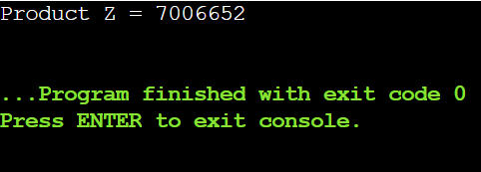

Result:
Multiplication performed efficiently.

